Power, Controls and Backplane for RoboSub

Systems Diagram

Functional Diagram Level 1

Responsibilities, Roles, and Components

20 September 2016

Ocean’s Seven

Hassan Alahmed

Abbigail Caballero

Kyle Harlow

Daniel Henderson

Yuvin Kokuhennadige

Larry Manalo

Cassandra Noice

**System Diagram**

Untitled Diagram.png

**Functional Diagram Level 0**

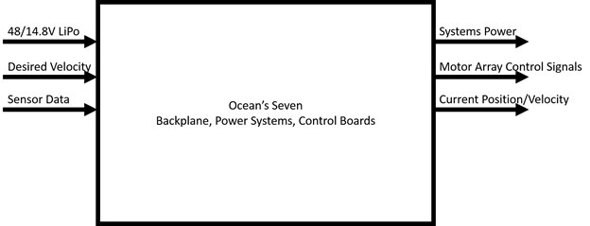

|  |  |
| --- | --- |
| Inputs | Description |
| 48/14.8V LiPo | External Power provided by Lithium Polymer Batteries. Currently have 14.8V LiPos, may invest in 48V so only buck conversion is necessary and the main drive motors can be operated at a higher voltage. |
| Desired Velocity | Orientation and velocity information provided by the CPU based current location and desired location |
| Sensor Data | IMU and DVL data to determine relative position, acceleration and velocity vectors. |

|  |  |
| --- | --- |
| Outputs | Description |
| Systems Power | 3.3V, 5V, 14.8V, and several more component specific voltage requirements to maintain power to all systems on the AUV |
| Motor Array Control Signals | PWM signals provided to the ESCs to regulate individual motor velocities. |
| Current Position and Velocity Vectors | Relative position and velocity vectors for use by the CPU and motion control systems to make decisions and calculate optimal pathing. |

**Functional Diagram Level 1**

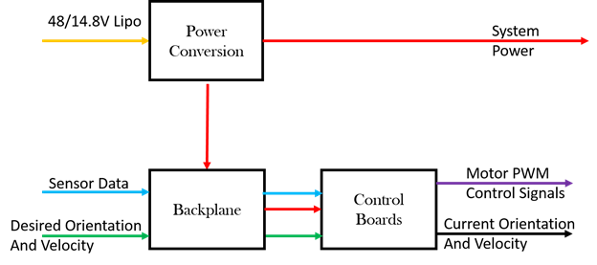

|  |  |
| --- | --- |
| System | Description |
| Power Conversion | A combination of buck and boost converters to translate the external power provided by the LiPos into the voltages and current capacities required by the array of electronic components in the AUV. |
| Backplane | Main hub for communications and power distribution. All PCBs will plug into the backplane, channel data streams through it, and draw power from it |
| Control Boards | A combination of a stability assisting controller that will ensure stable velocities in all axes of motion to ensure accurate maneuvering.    Pathing controller that will calculate how to efficiently achieve a desired trajectory based on the current trajectory. |

**Responsibilities Roles and Components**

Use Cases:

1. Systems Power Up

2. Execution of Normal Operations

3. Kill Switch Engaged

|  |  |  |  |
| --- | --- | --- | --- |
| Use Case Reference | Responsibilities | Roles | HW, SW Component, or Both |
| 1,2 | Buck conversion to 5V | Provide voltage and current requirements for IMUs, Microcontroller/FPGA, ESC PWM | Hardware:  14.8V to 5V DC buck converter  Software:  N/A |
| 1,2 | Boost conversion to 19V | Provide stable voltage and current requirements for CPU | Hardware:  14.8V to 19V DC boost converter  Software:  N/A |
| 1,2 | Boost Conversion to 48V | Provide voltage and current requirements for downward facing camera, DVL | Hardware:  14.8V to 48V DC boost converter  Software:  N/A |
| 2 | Movement Stabilizer | Maintain stable maneuvering | Hardware: 2xIMUs, DVL, 2x X Motors, 6x Y motor, MCU/FPGA    Software: PID or other control architecture implemented on an MCU or FPGA |
| 2 | Pathing Calculation | Calculate optimal path from current position/orientation to desired position/orientation | Hardware: 2xIMUs, DVL, 2x X Motors, 6x Y motor, MCU/FPGA    Software: Math, lots and lots of math. |
| 2 | Sensor and data logging | Feedback, performance analysis, etc.? | Hardware: IMUs, DVL, SD Card, MCU    Software: Data logging stuff. |
| 1 | Power on routine | Ensure systems power up in the appropriate order. Monitor voltage/current levels on major traces | Hardware: MCU, Current Sensors, Voltage Sensors    Software: Power Up Routine |
| 3 | Mechanical Kill Switch | Disable high power traces to motors | Hardware: Reed switch, magnetic catch    Software: |